**Amazon CloudWatch agent**

* This agent is an application that runs as a daemon or background application that collects and sends the logs to cloud watch
* Lets create an amazon linux ec2 instance and configure the cloudwatch agent
* Install Cloud watch agent <https://docs.aws.amazon.com/AmazonCloudWatch/latest/monitoring/download-cloudwatch-agent-commandline.html>   
  sudo yum install amazon-cloudwatch-agent -y  
  sudo /opt/aws/amazon-cloudwatch-agent/bin/amazon-cloudwatch-agent-config-wizard
* <https://docs.aws.amazon.com/AmazonCloudWatch/latest/logs/AgentReference.html> for log agent configuration
* Once we run the wizard and then try to answer questions then a config file will be created at /opt/aws/amazon-cloudwatch-agent/bin/config.json  
  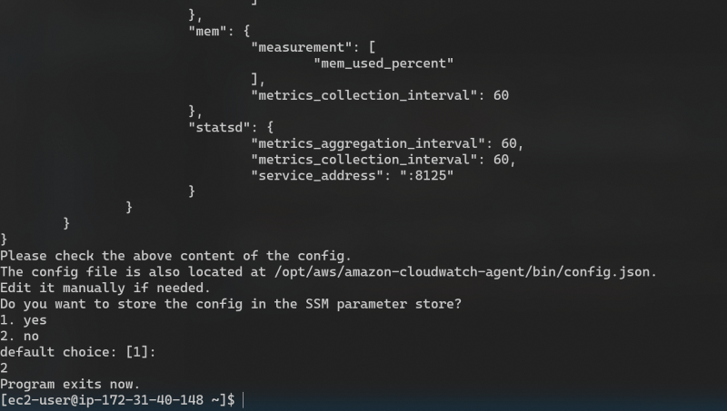
* For this ec2 instance to send logs to AWS we need to give permissions
* Create an IAM Role => This is applicable to ec2 instances only
* Create an IAM user and configure this => This can be done for ec2 instances as well as on-premises instances
* Lets create an IAM Role  
  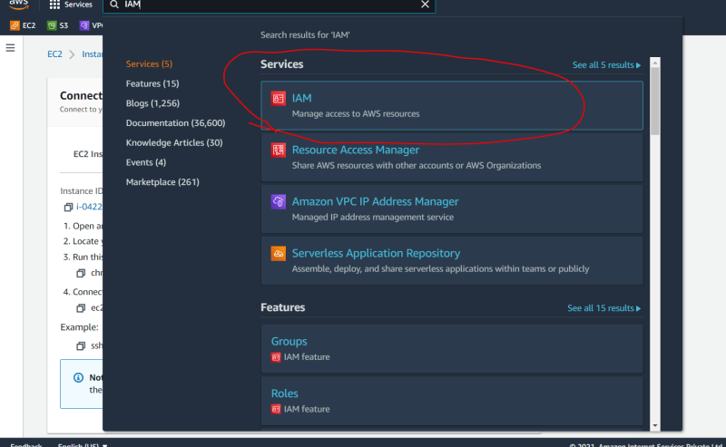  
  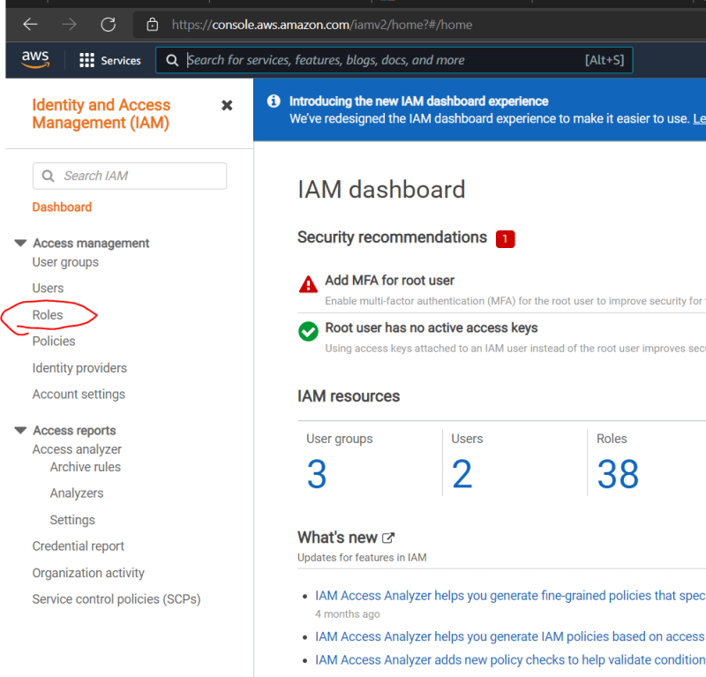  
  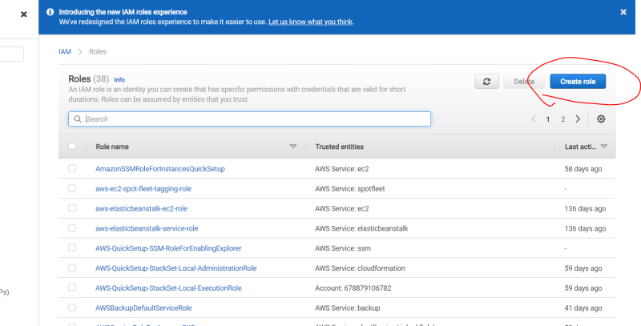  
  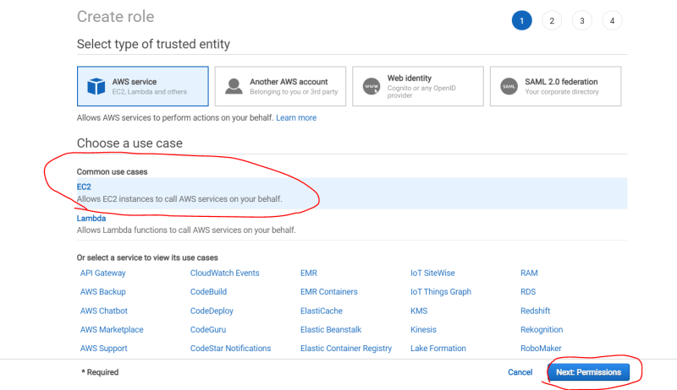  
  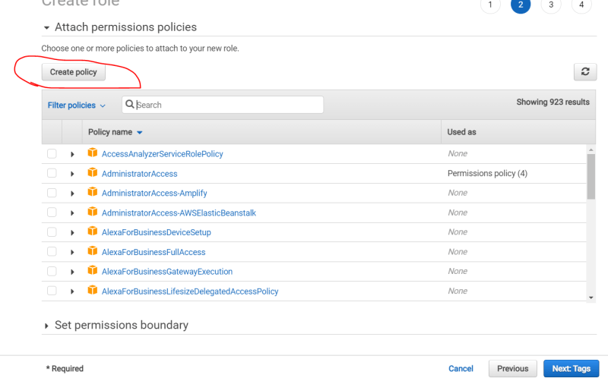  
  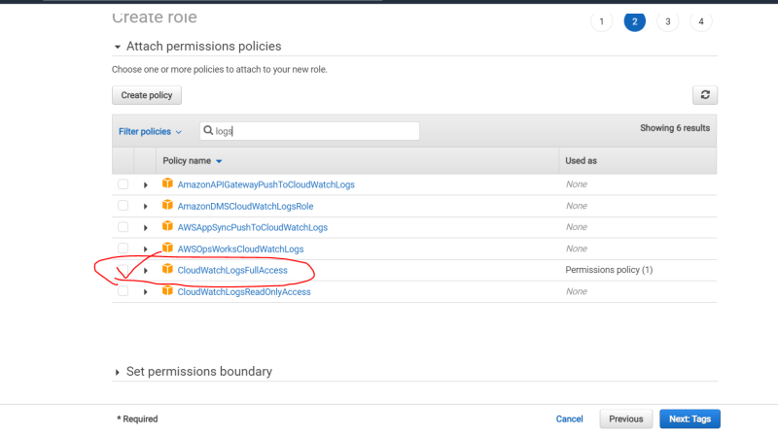  
  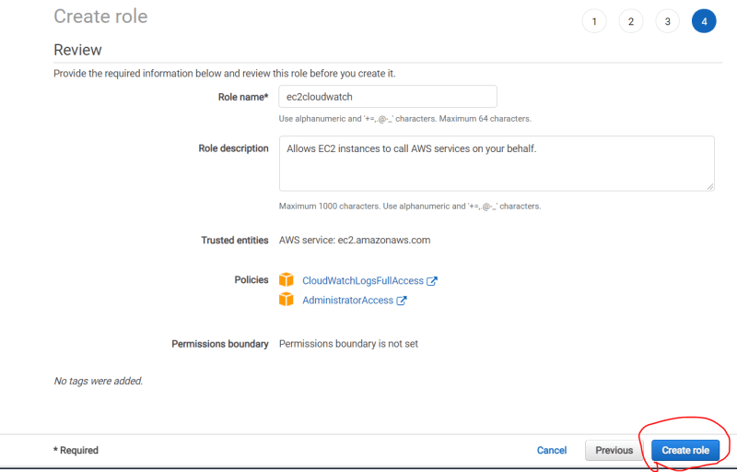
* Now lets apply this role to the ec2 instance  
  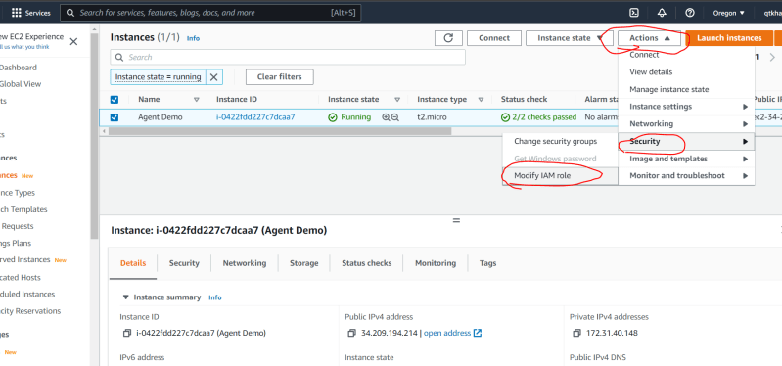  
  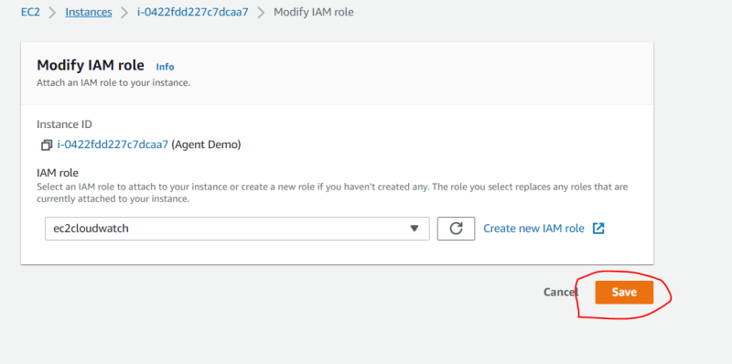
* Now lets install httpd on this ec2 instance  
  sudo yum install httpd -y  
  sudo systemctl enable httpd.service  
  sudo systemctl start httpd.service
* Now start the cloud watch agent  
  sudo amazon-cloudwatch-agent-ctl -a start
* Try to write some shell which will continuously access your apache server  
  bash  
  apache_url='http://34.209.194.214'  
  while true  
  do  
  curl ${apache_url}  
  sleep 5  
  done